**38**

**Relativity**

|  |
| --- |
| **CHAPTER OUTLINE** |

38.1 The Principle of Galilean Relativity

38.2 The Michelson-Morley Experiment

38.3 Einstein’s Principle of Relativity

38.4 Consequences of the Special Theory of Relativity

38.5 The Lorentz Transformation Equations

38.6 The Lorentz Velocity Transformation Equations

38.7 Relativistic Linear Momentum

38.8 Relativistic Energy

38.9 The General Theory of Relativity

* An asterisk indicates a question or problem new to this edition.

|  |
| --- |
| **ANSWERS TO THINK-PAIR-SHARE ACTIVITIES** |

**\*TP38.1** Conceptualize The combined mass of the initial black holes is larger than that of the final black hole. The difference in mass is radiated away by gravitational waves. The black holes rotate around each other before combining, and then the actual merger of the two occurs in a very short time interval, leading to a tremendous power output.

**Categorize** This problem involves a combination of our understanding of power from Chapter 7 and our understanding of rest energy from this chapter.

**Analyze** From the definition of power, we can find the power radiated away by gravitational waves by determining the change in mass during the process. For the first detection,

 (1)

and for the second,

 (2)

where *a* is our desired factor. Divide Equation (2) by Equation (1) and solve for *a*:



Substitute numerical values, expressing the mass changes as multiples of *M*, the mass of the Sun:



where we have kept only one significant figure because we only have one for ∆*t*1.

**Finalize** While this is a much smaller ratio than that for the first detection, it is still a tremendous outpouring of energy in a short time interval.]

*Answer:* 3

**\* TP38.2 Conceptualize** We only have two data points, so we should not expect high precision. Notice, however, that the neutrino with the higher energy arrived first. That is consistent with the fact that a higher energy means that the first neutrino is moving *faster,* since both neutrinos have the same rest energy.

**Categorize** The neutrinos move as *particles under constant velocity.*

**Analyze** Let’s look first at the arrival time data. If we call the early arriving neutrino *A* and the later one *B*, then the difference in arrival times is

 (1)

where we have used the particle under constant velocity model to find each time interval in terms of the neutrino speed and the distance *D* to the supernova. Solving Equation 38.8 for the speed of a particle, we can write Equation (1) as



Because the neutrinos travel with very high speed, the value of ** is high, and we can use the binomial expansion for each term, keeping only the first two terms:

 (2)

Now, let’s look at the energy data. We assume the detected neutrinos are of the same particle species, and therefore have the same mass. Equation 38.26 tells us that

 (3)

Substitute Equation (3) into Equation (2):

 (4)

Solve Equation (4) for :

 (5)

Use Equation 38.26 again to find the mass of the neutrino and substitute Equation (5):



Substitute numerical values:



**Finalize** This is a very small mass. It is remarkable that we have been able to come up with an estimate of the neutrino mass from measurements on only two neutrinos. We assumed that the neutrinos came from the same starting point in the supernova, but that’s highly unlikely. Therefore, *D* in the above calculation may be different for the two neutrinos, but we have no way of knowing the individual values. It is also unlikely that the neutrinos were emitted simultaneously, since the supernova process spans tens of seconds. Measurements on more neutrinos tighten up the precision for the calculation of the mass. Current experiments provide neutrino masses on the order of a few eV/*c*2 and sometimes less than 1 eV/*c*2.]

*Answer:* 45 eV/*c*2

|  |
| --- |
| **SOLUTIONS TO END-OF-CHAPTER PROBLEMS** |

Section 38.1 The Principle of Galilean Relativity

**P38.1** In the laboratory frame of reference, Newton’s second law is valid: . Laboratory observer 1 watches some object accelerate under applied forces. Call the instantaneous velocity of the object  (the velocity of object *O* relative to observer 1 in laboratory frame) and its acceleration . A second observer has instantaneous velocity  relative to the first. In general, the velocity of the object in the frame of the second observer is



(a) If the relative instantaneous velocity  of the second observer is *constant*, the second observer measures the acceleration



This is the same as that measured by the first observer. In this nonrelativistic case, they measure the same forces and masses as well. Thus, the second observer also confirms that 

(b)If the second observer’s frame is accelerating, then the instantaneous relative velocity  is *not constant*. The second observer measures an acceleration of



where 

The observer in the accelerating frame measures the acceleration of the mass as being  If Newton’s second law held for the accelerating frame, that observer would expect to find valid the relation  or  (since  and the mass is unchanged in each). But, instead, the accelerating frame observer finds that  which is *not* Newton’s second law.

**P38.2** In the rest frame,



Since 



In the moving frame, these velocities are all reduced by +10.0 m/s.



Our initial momentum is then



and our final momentum has the same value:



Section 38.4 Consequences of the Special Theory of Relativity

**P38.3** (a) The length of the meter stick measured by the observer moving at speed *v* = 0.900 *c* relative to the meter stick is



(b) If the observer moves relative to Earth in the direction opposite the motion of the meter stick relative to Earth, the velocity of the observer relative to the meter stick is greater than that in part (a). The measured length of the meter stick will be  under these conditions, but so small it is unobservable.

**P38.4** For , 

(a) The muon’s lifetime as measured in the Earth’s rest frame is



and the lifetime measured in the muon’s rest frame is



(b) In the muon’s frame, the Earth is approaching the muon at speed *v* = 0.990*c*. During the time interval the muon exists, the Earth travels the distance



**P38.5** The astronaut’s measured time interval is a proper time in her reference frame. Therefore, according to an observer on Earth,



**P38.6** (a) The time interval between pulses as measured by the astronaut is a proper time:



The time interval between pulses as measured by the Earth observer is then:



Thus, the Earth observer records a pulse rate of



(b) From part (a), the pulse rate is



That is, the life span of the astronaut (reckoned by the duration of the total number of his heartbeats) is much longer as measured by an Earth clock than by a clock aboard the space vehicle.

**P38.7** From the definition of 



we solve for the speed:



**\*P38.8 Conceptualize** The driver is claiming an Earth-based version of the Doppler shift for light, which causes light from galaxies receding from us to experience a redshift. Because the driver is moving toward the light source, the wavelength should be shifted toward the blue end of the spectrum.

**Categorize** We use our understanding of the Doppler effect for light.

**Analyze** Solve Equation 38.10 for the relative speed between the driver and the traffic light when they are moving toward each other:

 (1)

Express Equation (1) in terms of wavelengths:

 (2)

Substitute numerical values:



A speed of 22% of the speed of light is well over the speed limit of any Earth-based road. The driver’s own testimony shows him blatantly violating any Earth-based speed limit; look for another defense.

**Finalize** The speed found in the problem is equivalent to 6.59 × 107 m/s, or 1.47 × 108 mi/h. Such speeds are not possible with automobiles or other Earth-based vehicles, so it is clear that the Doppler shift of light is not a phenomenon with which we have to deal on an everyday basis.]

*Answer:* The driver’s own testimony shows him blatantly violating any Earth-based speed limit; look for another defense.

**P38.9** The spaceship is measured by the Earth observer to be length-contracted to

 or 

Also, the contracted length is related to the time required to pass overhead by

 or 

Equating these two expressions gives 

or 

Using the given values *Lp* = 300 m and , this becomes



giving 

**P38.10** The spaceship is measured by Earth observers to be of length *L*, where



and 

 and 

Solving for *v*,



giving 

**P38.11** (a) When the source moves away from an observer, the observed frequency is



where  because the source is moving away from the observer.

When , the binomial expansion gives



So, 

The observed wavelength is found from :



Since , 

(b) We use the equation from part (a) with the given values:



**P38.12** The relativistic density is



**P38.13** We find Cooper’s speed from Newton’s second law:



Solving,



Then the time period of one orbit is



(a) The time difference for 22 orbits is

 



(b) For each one orbit Cooper aged less by



The press report is .

**\*P38.14** **Conceptualize** The time interval to wait will involve two considerations: (1) the time interval for the exam will appear dilated to the professor on Earth *and* (2) there will be a time interval required for the radio signal to reach the spacecraft.

**Categorize** This problem will involve time dilation for the exam as well as the *particle under constant velocity* model applied to the radio signal.

**Analyze** The dilated time interval for the exam to be finished, as measured by the professor, is given by Equation 38.7:

 (1)

where ∆*tp* is the proper time interval of 2.00 hr for the students to take the exam. This time interval consists of two parts for the professor on Earth, the time interval to wait before sending the signal to stop the exam plus the time interval required for the signal to reach the spacecraft:

 (2)

Therefore, the time interval that we want to determine to answer the question is

 (3)

The travel time for the signal can be found from the particle under constant velocity model. The time interval is the ratio of the distance to the spacecraft when the signal arrives to the speed of light. The distance to the spacecraft, as measured by the professor, is the product of its speed and the dilated time interval for the exam:

 (4)

On the right-hand side of Equation (3), substitute Equation (4) for the second term and solve for ∆*t*wait:

 (5)

Now substitute Equation (1) into Equation (5):



Substitute numerical values:



**Finalize** Notice that the waiting time is much less than the 2.00 h for the exam. The individual pieces of this waiting time are longer and are found from Equations (1) and (4):





Of course, it would be a lot easier to just have a proctor traveling with the students give them 2.00 h before signaling them by voice to stop!]

*Answer:* 0.286 h = 17.1 min

**P38.15** (a) The mirror is approaching the source. Let *fm* be the frequency as seen by the mirror. Thus,



After reflection, the mirror acts as a source, approaching the receiver. If *f'* is the frequency of the reflected wave,



Combining gives



(b) Using the above result, the beat frequency is



(c) The wavelength is



The beat frequency is therefore,



(d) From part (b), , so



**Section 38.5 The Lorentz Transformation Equations**

**P38.16** Let Shannon be fixed in reference from S and see the two light-emission events with coordinates *x*1 = 0, *t*1 = 0, *x*2 = 0, *t*2 = 3.00 *µ*s. Let Kimmie be fixed in reference frame S*'* and give the events coordinate , , 

(a) Then we have







(b) The coordinate separation of the events is





The later pulse is to the left of the origin.

**P38.17** The rod’s length perpendicular to the motion is the same in both the proper frame of the rod and in the frame in which the rod is moving– our frame:



where  is the *y* component of the proper length.

We are given: , and  both measured in our reference frame. Also,



As observed in our frame,



and 

 is a proper length, related to  by 

Therefore, 

and 

(a) 

(b) In the proper frame,

 

**P38.18** (a)  and .

Since the motion is in the *x* direction, the length of the rod in the *y* direction does not change:  and



Thus,



or .

(b) 

**P38.19** (a) From the Lorentz transformation, the separations between the blue-light and red-light events are described by

: 



so 

(b) Again from the Lorentz transformation, :



(c) :





**Section 38.6 The Lorentz Velocity Transformation Equations**

**\*P38.20 Conceptualize** Place the S frame on the Earth. Place the S’ frame on the police spacecraft. An observer on the police spacecraft is measuring the speed of the driver’s spacecraft.

**Categorize** We need to make a simple velocity transformation, so this problem is categorized as a substitution problem.

We want the speed of the spacecraft relative to the S frame, so we use Equation 38.18:



Substitute numerical values:



The driver was traveling above the speed limit relative to the Earth, so the lawyer cannot use these data to defend his client. He will need to search elsewhere for a defense.]

*Answer:* The driver was traveling at 0.763*c* relative to the Earth. He was speeding.

**P38.21** Take the galaxy as the unmoving frame. Arbitrarily define the jet moving upward to be the object, and the jet moving downward to be the “moving” frame:

**ANS. FIG. P38.21**

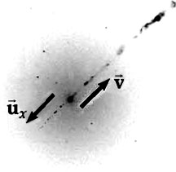

 velocity of other jet in

frame of jet

*ux* = velocity of other jet in

frame of galaxy center

= 0.750*c*

*v* = speed of galaxy center in frame of jet = –0.750*c*

From Equation 38.16, the speed of the upward-moving jet as measured from the downward-moving jet is 

**P38.22** Let frame *S* be the Earth frame of reference. Then *v* = –0.700*c.*

The components of the velocity of the first spacecraft are



and 

As measured from the *S*’ frame of the second spacecraft,



and



The magnitude of  is 

and its direction is at .

**Section 38.7 Relativistic Linear Momentum**

**P38.23** (a)  for an electron moving at 0.010 0*c*,



Thus, 



(b) Following the same steps as used in part (a), we find at 0.500*c*,   
*γ* = 1.15 and



(c) At 0.900*c*, *γ* = 2.29 and



**P38.24** From the definition of relativistic linear momentum,



we obtain



which gives:



or  and .

**P38.25** (a) Classically,



(b) By relativistic calculations,



(c)  neglecting relativistic effects at such speeds would introduce an approximate 86% error in the result.

**P38.26**  We can express the proportion relating the speeding fine to the excess momentum as , where *F* is the fine,  is the magnitude of the vehicle’s momentum at speed *u*, and *c* = 1.08 × 109 km/h. After substitution of the expression for momentum, the proportion becomes



(a) For *u* = 1 090 km/h,



(b) For *u* = 1 000 000 090 km/h,







**P38.27** Relativistic momentum of the system of fragments must be conserved. For total momentum to be zero after as it was before, we must have, with subscript 2 referring to the heavier fragment, and subscript 1 to the lighter, p2 = p1,

or 

or 

Proceeding to solve, we find



 and 

**Section 38.8 Relativistic Energy**

**P38.28** (a) Using the classical equation,



(b) Using the relativistic equation, 



(c) When , the binomial series expansion gives



Thus,  and the relativistic expression for kinetic energy becomes  That is, in the limit of speeds much smaller than the speed of light, the relativistic and classical expressions yield the same results. In this situation the two kinetic energy values are experimentally indistinguishable. The fastest-moving macroscopic objects launched by human beings move sufficiently slowly compared to light that relativistic corrections to their energy are negligible.

**P38.29** We use the equation . For an electron, 

(a) 

(b) 

**P38.30** The relativistic kinetic energy of an object of mass *m* and speed *u*

is  The classical equation is . Their ratio is



For still smaller speeds the agreement will be still better.

**P38.31** (a) To find the speed of the protons with  we write



So, 

(b) From Example 38.9, for a proton, *mc*2 = 938 MeV. Then



**\*P38.32** **Conceptualize** Wouldn’t it be wonderful if such a reactor existed? You would simply feed the matter and antimatter into the machine and they would annihilate, releasing their *entire* rest energy. In reality, of course, we don't have a supply of a large amount of antimatter. While antimatter is produced in particle accelerators and stored for future experiments, the total amount of antimatter produced in this way would not boil a cup of tea if annihilated completely with matter. Producing enough antimatter for the proposal in this problem would be horrendously cost-prohibitive, but let’s carry on anyway!

**Categorize** The matter and antimatter would be modeled as an *isolated system* for *energy,* in which the rest energy transforms entirely to other forms, all of which can theoretically be used to supply the world’s energy needs.

**Analyze** (a) Solve Equation 38.24 for the mass needed to transform the rest energy into other forms of energy:

 (1)

Substitute numerical values for the transformed rest energy to be equal to the world’s energy requirement for one year:



This is the total mass to be transformed. Half of this mass is matter and half is antimatter, so



(b) Now, let’s address the 5.0-yr supply. The amount of mass of either matter or antimatter that will have to be stored is



Use Equation 1.1 to find the volume in which this mass must be stored:



Therefore, each of the matter and antimatter could be stored in a cubic container about 1.6 m on a side.

**Finalize**  How realistic is this proposal? Not realistic at all, at least with today’s technology and scientific understanding. The concept of generating energy with no waste is optimistic. Even if we imagine that waste energy in the form of internal energy could be used to warm houses and commercial buildings, how do we transport that energy to the site? How do we feed the matter and antimatter in at a slow enough rate so that the reactor does not explode? How can we store antimatter on a world made of matter?]

*Answers:* (a) 2.2 × 103 kg for each of matter and antimatter (b) 4.1 m3 for each of matter and antimatter

**P38.33** Given *E* = 2*mc*2, where *mc*2 = 938 MeV from Example 38.9. We use Equation 38.27:



Solving for the momentum then gives



**P38.34**  (a)  leaves the system, so the final mass is 

(b) The mass-energy relation says that *E = mc*2. Therefore,



(c) 

**P38.35** From  we have





(a) Electron: 

(b) Proton: 

(c) 

In this case the electron is moving relativistically, but the classical expression  is accurate to two digits for the proton.

(d) Electron: 

Proton: 

Then,



As the kinetic energies of both particles become large, their speeds approach *c*. By contrast, classically the speed would become large without any finite limit.

**P38.36** We are told to start from  and  Squaring both equations gives

 and 

We choose to multiply the second equation by c2 and subtract it from the first:



We factor to obtain



Extracting the (mc2) factors gives



We substitute the definition of 



The factors divide out, leaving



**P38.37** Let *m* = 1.99 × 10−26 kg, and  An isolated system of two particles of mass *m* and *m*′ = *m*/3collide with the respective velocities  and , resulting in a particle with mass *M* and velocity  By conservation of the *x* component of momentum (*γ mu*):

 **[1]**

By conservation of total energy (*γ mc*2):

 **[2]**

To start solving, we divide the momentum equation [1] by the energy equation [2], giving .

Then, substituting the value of the final speed back into the energy equation [2], we get



**P38.38** (a) By conservation of the *x* component of momentum (*γ mu*):

 **[1]**

By conservation of total energy (*γ mc*2):

 **[2]**

To start solving, we divide the momentum equation [1] by the energy equation [2], giving . Then, substituting the value of the final speed back into the energy equation [2], we get



(b) As , 

(c) 

**P38.39** The kinetic energy of the car is given by



We use the series expansion from Appendix B.5:





The actual kinetic energy, given by this relativistic equation, is  than the classical 

The difference, for *m* = 1 000 kg and *u* = 25 m/s, is



**P38.40** (a) The initial system is 

(b) 

(c) We must conserve both energy and relativistic momentum of the system of fragments. With subscript 1 referring to the 0.987*c* particle and subscript 2 to the 0.868*c* particle,

**ANS. FIG. P38.40**

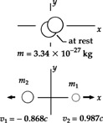

 and



(d) Conservation of energy gives 

which is



or 

This reduces to:  **[1]**

(e) Since the final momentum of the system must equal zero, *p*1 = *p*2 gives



or 

which becomes  **[2]**

(f) Substituting [2] into [1] gives



thus,  and 

**Section 38.9 The General Theory of Relativity**

**P38.41** (a) For the satellite, Newton’s second law gives



which gives



Solving for the orbital radius,



(b) 

(c) From the relationship of frequency and period:



We see the fractional decrease in frequency is equal in magnitude to the fractional change in period.

The small fractional decrease in frequency received is equal in magnitude to the fractional increase in period of the moving oscillator due to time dilation:





(d) The orbit altitude is large compared to the radius of the Earth, so we must use



The change in gravitational potential energy is



Then



(e) 

**Additional Problems**

**P38.42** From the particle under constant speed model, find the travel time for Speedo from Goslo’s reference frame:



Therefore, when Speedo arrives back on Earth, 118 years have passed and Goslo would have to be 158 years old. Furthermore, Speedo will be 102 years old. Perhaps future medical breakthroughs may extend the life expectancy to 158 years and beyond, but that is impossible at present.

**P38.43** (a) Observers on Earth measure the distance to Andromeda to be



The time for the trip, in Earth’s frame of reference, is



The required speed is then



which gives, suppressing units,



Squaring both sides of this equation and solving for *v/c* yields



Then, the approximation  gives



**P38.44** (a) We let *H* represent  Then,



so 

Solving,



and 

(b) 

(c) 

(d) The acceleration is given by







where .

(e) When *H* is small (), we have approximately



in agreement with the nonrelativistic case.

(f) When *H* is large the acceleration approaches



(g) 

**P38.45** (a) From Problem 43,



and



(b) The astronaut’s speed, from Problem 43, is



The time difference between the astronaut’s trip and that of the beam of light is then



Where  Substituting numerical values,



**P38.46** (a) From Equation 38.18, the speed of light in the laboratory frame is



(b) When *v* is much less than *c* we have



(c) If light travels at speed *c*/*n* in the water, and the water travels at speed *v*, then the Galilean velocity transformation Equation 4.20 would indeed give *c/n* + *v* for the speed of light in the moving water. The third term – *v*/*n*2 does represent a relativistic effect that was observed decades before the Michelson-Morley experiment. It is a piece of twentieth-century physics that dropped into the nineteenth century. We could say that light is intrinsically relativistic.

(d) To take the limit as *v* approaches *c* we must go back to . As ,



**P38.47** The energy of the first fragment is given by





For the second,





(a) Energy is conserved, so the unstable object had  Each component of momentum is conserved, so for the original object



Then, using Equation 38.27, we find the mass of the original object:







(b) Now  gives



 which gives 

**P38.48** We find the speed of the electrons after accelerating through a potential difference  from Equation 38.23:



then



or



Solving,



Substituting numerical values and suppressing units,



Because this speed is more than half the speed of light, there is no way to double its speed, regardless of the increased accelerating voltage. If the accelerating voltage is quadrupled to 336 kV, the speed of the electrons rises to *u* = 0.798*c*.

**P38.49** (a) The speed of light in water is *c*/1.33, so the electron’s speed is 1.10*c*/1.333. Then



and the total energy is

**

(b) The electron’s kinetic energy is



(c) The electron’s momentum is found from



and



(d) From Figure 16.26, the angle between the particle (source of waves) and the shock wave is



where *v* is the wave speed, which is the speed of light in water, and  is the source speed. Then



**P38.50** (a) Take *m* = 1.00 kg. The classical kinetic energy is



and the actual kinetic energy is



Using these expressions, we generate the graph in ANS. GRAPH P38.50.



**ANS. GRAPH P38.50**

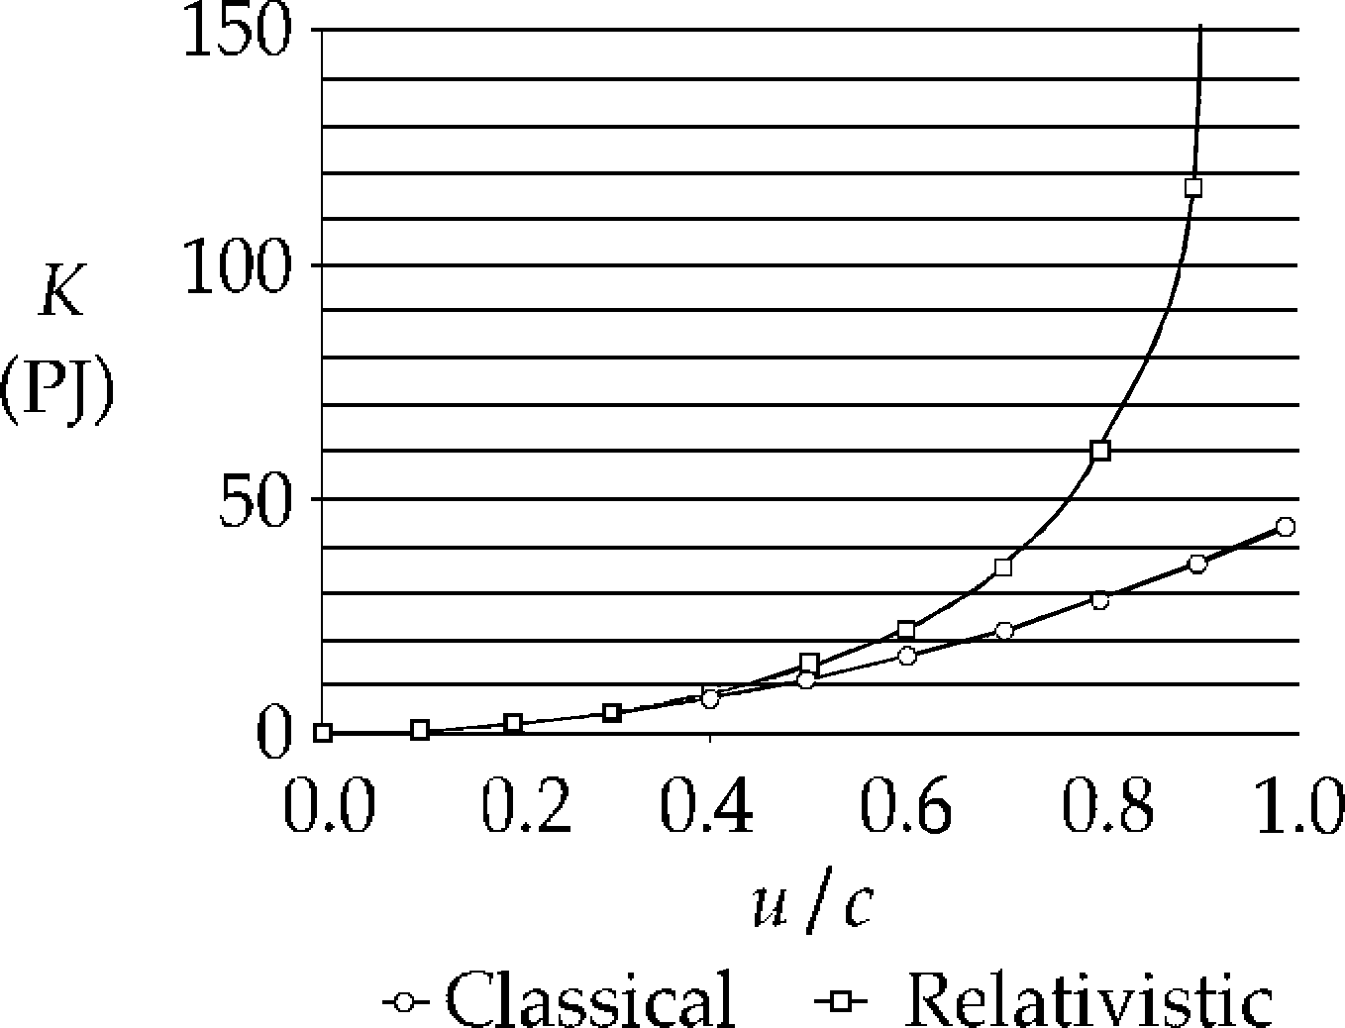

(b) , when , yielding



(c) Similarly,  when 

(d)  when 

**P38.51** (a) Assuming the Sun-mass system is isolated, the energy (work) required to remove a mass *m* from the Sun’s surface to infinity is equal to the change in potential energy of the system. If the work equals the rest energy *mc*2, then



(b) 



**P38.52** Since the total momentum is zero before decay, it is necessary that after the decay



Also, for the recoiling nucleus, with



Thus, 

or



Because the term , evaluating  on a calculator gives 1.

We need to expand  using the Binomial Theorem:





**Challenge Problems**

**P38.53** (a) Take the two colliding protons as the system

 

 

In the final state,



By energy conservation, , so





By conservation of momentum, , so



and we have then





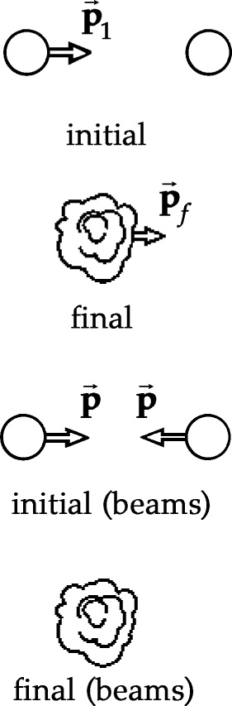

**ANS. FIG. P38.53**

(b) By contrast, for colliding beams we have, in the original state,

 

In the final state,



:





**P38.54** (a) At any speed, the momentum of the particle is given by



With Newton’s law expressed as , we have





so 

and 

(b) For *u* small compared to *c*, the relativistic expression reduces to the classical . As *u* approaches *c*, the acceleration approaches zero, so that the object can never reach the speed of light.

(c) We can use the result of (a) to find the velocity *u* at time *t*:



Now, we can use this result to find position *x* at time *t*:



**P38.55** We choose to write down the answer to part (b) first.

(b) Consider a hermit who lives on an asteroid halfway between the Sun and Tau Ceti, stationary with respect to both. Just as our spaceship is passing him, he also sees the blast waves from both explosions. Judging both stars to be stationary, this observer concludes that 

(a) We in the spaceship moving past the hermit do not calculate the explosions to be simultaneous. We measure the distance we have traveled from the Sun as



We see the Sun flying away from us at 0.800*c* while the light from the Sun approaches at 1.00*c*. Thus, the gap between the Sun and its blast wave has opened at 1.80*c*, and the time we calculate to have elapsed since the Sun exploded is



We see Tau Ceti as moving toward us at 0.800*c*, while its light approaches at 1.00*c*, only 0.200*c* faster. We measure the gap between that star and its blast wave as 3.60 ly and growing at 0.200*c*. We calculate that it must have been opening for



and conclude that .

|  |
| --- |
| **ANSWERS TO QUICK-QUIZZES** |

1. (c)

**2.** (d)

**3.** (d)

**4.** (a)

**5.** (c)

**6.** (d)

**7. (i)** (c) **(ii)** (a)

**8.** (a) > =  (b)  =  >  (c) >  = 

|  |
| --- |
| **ANSWERS TO EVEN-NUMBERED PROBLEMS** |

**P38.2** See P38.2 for full explanation

**P38.4** (a) ; (b) 649 m

**P38.6** 65.0 beats/min; (b) 10.5 beats/min

**P38.8** The driver’s own testimony shows him blatantly violating any Earth-based speed limit; look for another defense.

**P38.10** 

**P38.12** 42.1 g/cm3

**P38.14** 0.286 h = 17.1 min

**P38.16** (a) *v* = 0.943*c*; (b) 2.55 × 103 m

**P38.18** (a) ; (b) 

**P38.20** The driver was traveling at 0.763*c* relative to the Earth. He was speeding.

**P38.22** 0.893c, 16.8° above the *x*’ axis

**P38.24** 

**P38.26** (a) $800; (b) $2.12 × 109

**P38.28** (a) 4.38 × 1011 J; (b) 4.38 × 1011; (c) See P39.48(c) for full explanation.

**P38.30** See P38.30 for full explanation.

**P38.32** (a) 2.2 × 103 kg for each of matter and antimatter (b) 4.1 m3 for each of matter and antimatter

**P38.34** (a) ; (b) ;

(c) 

**P38.36** See P38.36 for full explanation.

**P38.38** (a) ; (b) ; (c) The answer to part (b) is in agreement with the classical result, which is the arithmetic sum of the masses of the two colliding particles.

**P38.40** (a) isolated; (b) isolated system: conservation of energy and isolated system: conservation of momentum; (c) 6.22 and 2.01;   
(d) ; (e) ;   
(f)  and 

**P38.42** When Speedo arrives back on Earth, 118 years have passed, and Goslo would be 158 years old. That is impossible at the present time.

**P38.44** (a) ; (b) *u* goes to 0 as *K* goes to 0; (c) *u* approaches *c* as *K* increases without limit; (d) ; (e) See P39.74(e) for full explanation; (f) See P39.74(f) for full explanation; (g) As energy is steadily imparted to particle, the particle’s acceleration decreases. It decreases steeply, proportionally to 1/*K*3 at high energy. In this way the particle’s speed cannot reach or surpass a certain upper limit, which is the speed of light in vacuum.

**P38.46** (a–c) See P38.46 for full explanation; (d) *c*

**P38.48** See P38.48 for full explanation

**P38.50** (a) See ANS GRAPH P38.50 (b)  (c)  (d) 

**P38.52** 

**P38.54** (a)  ; (b) See P38.54 (b) for full explanation; (c) , 